**Unit Two: Caring for Ourselves**

**Lesson 9: Rights of the Child**

Name: __________________________________ Date: _______________________

**Sara Tells Her Story**

Everybody calls me Cinderella instead of Sara. One of my stepsisters gave me this name because I used to clean the cinder in the fireplace. Everyone might know how my life looks like, but no one knows why my grandmother helped me.

One day, as I was doing the housework, two men knocked on the door. They gave my stepmother an envelope which was an invitation to the richest and the most handsome gentleman's birthday party.

When my stepmother told her daughters of the coming event, they were very excited. They tried on every single dress they owned. They wanted to look very beautiful at the party. On the other hand, I had to iron the clothes, fix my sisters' hairdos, and put everything back in its place.

By the end of the day, I was exhausted. I miserably watched them get into the car and leave for the party. I really wanted to go with them, but that was only a dream.

Hopelessly, I went to my bedroom. I cried so hard. Suddenly, the phone rang and when I answered, I heard a kind voice saying: "Sara, I’m your grandmother. You are not feeling well. What's the matter?

I told my grandmother the whole story. I told her that I had never been to school. I told her how much I worked to please my stepmother and her daughters, but I never could. My grandmother was confused and said, "My unfortunate child, you are like all other children. It's your right to have proper health care. It's your right to go to school."

“Is this the right of every child?" I interrupted.

"Of course, Sara. All children are equal, every child on Earth has these rights," she said. Then an idea came to my mind and I asked, "Do I have the right to entertain myself?"

"Of course, you do. It's your right to be happy, Sarah." Grandmother said gently. Then she asked me, "Would you like to go to the party?" Of course, my answer was "Yes."

Suddenly, everything changed in my life. I was amazed at what I saw and what I heard. I still live in that dream.

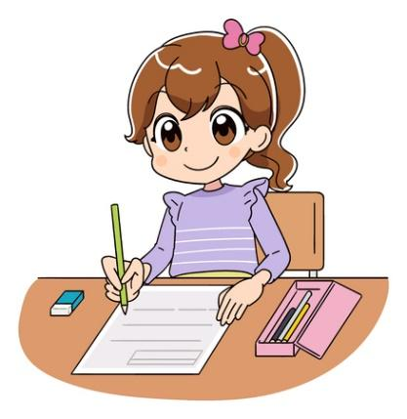

Name: ____________________________________ Date: ____________________

1. **Referring to the story “Sara Tells Her Story”, pick out three rights of a child.**
2. _____________________________________________________________________
3. _____________________________________________________________________
4. _____________________________________________________________________
5. **Classify the following phrases in the chart below as children’s rights and children’s responsibilities.**
6. respect others 4. to be loved and accepted
7. have proper medical care 5. live in a safe place
8. never hurt others 6. help who are in need

| **Children’s Rights** | **Children’s Responsibilities** |
| --- | --- |
|  |  |
|  |  |
|  |  |

1. **Think of one right and one responsibility and list them below.**
2. Right: ________________________________________________________________________
3. Responsibility: _________________________________________________________________

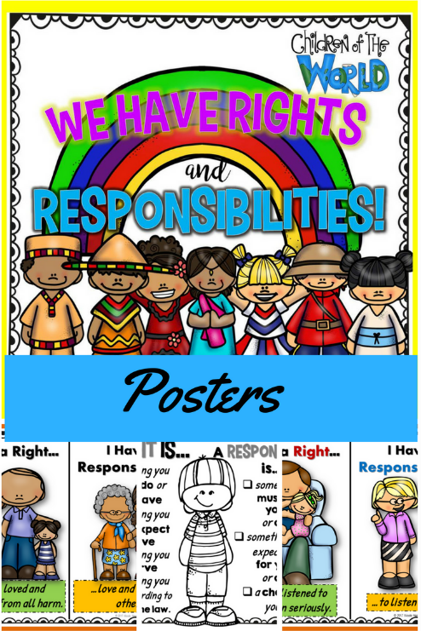

Name: ____________________________________ Date: ____________________

1. **Circle the correct spelling of the word after adding (*ly)* to it.**

| 1. **nice** | 1. nicely | 1. nicily | 1. nicly |
| --- | --- | --- | --- |
| 1. **excited** | 1. excitedely | 1. excitedly | 1. excitedily |
| 1. **happy** | 1. happyly | 1. happely | 1. happily |
| 1. **kind** | 1. kindly | 1. kindely | 1. kindily |
| 1. **entire** | 1. entirily | 1. entirely | 1. entirly |
| 1. **noisy** | 1. noisily | 1. noisely | 1. noisly |
| 1. **beautifu** | 1. beautifully | 1. beautifuly | 1. beautifuley |
| 1. **quiet** | 1. quietily | 1. quietely | 1. quietly |

1. **Add (ly) to the following words. Write the new word on the line.**
2. sleepy: ____________________ 3. dense: ____________________
3. healthy: ___________________ 4. hungry: ___________________
4. **Choose four of the above words and use each in a sentence to tell about Sara.**
5. **________________________________________________________________________________**
6. **________________________________________________________________________________**
7. **________________________________________________________________________________**
8. **________________________________________________________________________________**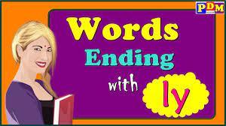

Name: ____________________________________ Date: ____________________

1. **Fill in the story map below about the story “Sara Tells Her Story”.**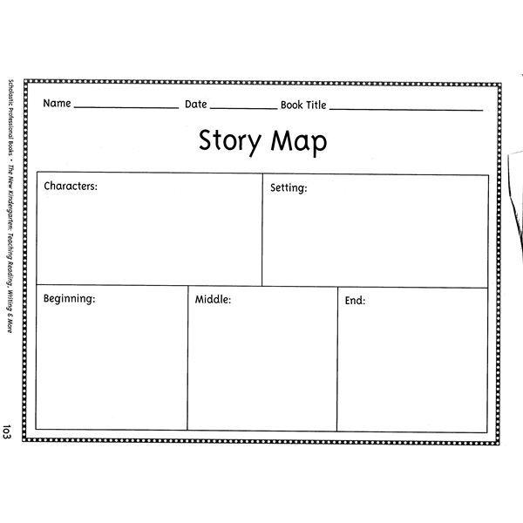

**B. Use the information from the above chart to write a summary for the story.**

______________________________________________________________________________________________________________________________________________________________________________________________________________________________________________________________________________________________________________________________________________________________________________________________________________________________________________

**C. Sara listened to her grandmother and went to the party. Write a short paragraph telling what happened with her there.**

________________________________________________________________________________________________________________________________________________________________________________________________________________________________________________________________________________________________________________________________________________________

Name: ____________________________________ Date: ____________________

1. **Circle the regular past tense verbs and underline the irregular past tense verbs in the chart below.**

| asked | rescued | said | was | gave | told | made | went | sent | lived |
| --- | --- | --- | --- | --- | --- | --- | --- | --- | --- |
| brought | heard | came | met | ran | read | saw | felt | drank | drew |

1. **Fill in the blanks with words from the above exercise to complete the following story.**

Once upon a time, there ____________________ a lion who __________________ in a gigantic forest. While walking proudly, he __________________ a mouse. Trying to catch her, she _________________ him not to do so for all the animals in the forest are frightened of her. To prove herself, she _____________________ the lion to have a walk with her. On their way, they __________________ the birds, the squirrels and the monkeys who directly ___________________ away. The lion was surprised of their reactions forgetting about himself being the king of the forest and the one that all creatures are afraid of.

1. **Change the following sentences from the present tense into the past tense.**
2. The students play together in the nearby garden.

________________________________________________________________________________

1. We write a letter to our friend who is absent.

_________________________________________________________________________________

1. Every summer, I swim with my siblings in our big pool.

________________________________________________________________________________

1. The girls jump rope during their free time.

_________________________________________________________________________________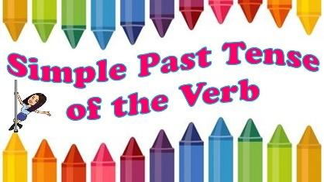

Name: ____________________________________ Date: ____________________

**Sam**

In a small village in South Africa there lived a boy named Sam. Sam's family was very poor. Many nights the family went to bed hungry. Sam's mother worried about her son. She wanted him to have a better future. She wanted him to grow up strong and to have a job.

When Sam was about eight years old, some men came to the village. They said they wanted to train the children to make carpets. They even told the villagers that they would pay the children for learning this trade.

Sam's mother thought this was a chance to help her son, so she sent him with the men. The men forced him to work 14 hours each day. They gave him 25 cents a day.

One day when Sam was nine years old some people came to rescue him and the other children who were forced to work like him. One of those people was a young boy from Britain called William Frank.

*Who Is William Frank?*

William Frank is a young British boy. In 1995 when he was 12, he read an article about a young boy from called "Dani " who was sold into slavery at the age of four. Dani had to work 12 hours a day, 6 days a week.

William then decided to do something about it. He worked with his friends to stop young people from being forced into labor.

William now travels to many different parts of the world where children are forced into labor. He appears on TV to talk about the rights of children. He sometimes goes and rescues children from slavery. He says the solution to the problem is education.

William still has time to go to school. He also does things that other young people his age do. For instance, he likes to play computer games when he is free.

Name: ____________________________________ Date: ____________________

1. **Referring to the two stories, fill in the Venn Diagram to compare and contrast *“Sara Tells Her Story”* And *“Sam”.***

Sara Tells Her Story Both Sam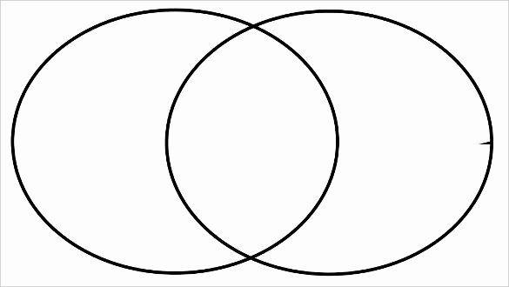

1. **Using the ideas from the above diagram, write a short paragraph that includes two similarities and two differences between the two given stories. Use clue words like both, also, but, and while….**

____________________________________________________________________________________________________________________________________________________________________________________________________________________________________________________________________________________________________________________________________

1. **What character did you like more, Sara or Sam? Why?**

___________________________________________________________________________________________________________________________________________________________________________________________________________________________________________________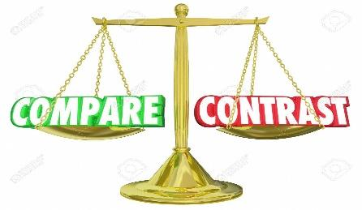

Name: ____________________________________ Date: ____________________

1. **Fill in the following web about William Frank’s date of birth, place of birth, nationality, interests, and hobbies.** 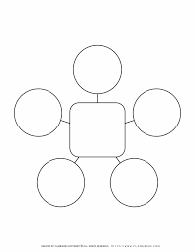



1. **It’s your turn now. Fill in the form below about yourself. Then, present yourself to your classmates.**

| **Name** |  |
| --- | --- |
| **Date of Birth** |  |
| **Place of Birth** |  |
| **Nationality** |  |
| **Hobbies** |  |
| **Interests** |  |

